Wickr RAM Desktop Client Install & Configuration

Wickr RAM is authorized for installation on government devices as well as personal devices including up to burner devices. These instructions cover how to install and configure your Wickr RAM client for desktop; Windows, Mac, and Linux Operating Systems (OS’s).  
  
For Mobile instructions please visit: [**https://ram.josce.net/install/static/guides/WickrRAMMobileInstallChecklist.docx**](https://ram.josce.net/install/static/guides/WickrRAMMobileInstallChecklist.docx)

# Downloading the Wickr Client

Wickr RAM uses the Wickr Enterprise client. Windows and Mac clients, for personal or burner devices, can be downloaded at[**https://ram.josce.net/install**](https://ram.josce.net/install).



For government devices, please check your respective SW centers.

Linux clients are available at [**Install Wickr Enterprise on Linux | Snap Store**](https://snapcraft.io/wickrenterprise)**.**

***Note:*** *Government managed devices may or may not have the Wickr Client on MS Software Center or on a network/shared drive or allow downloading and installing without administrator rights.  If you are unable to download or install, please contact your local IT support team for assistance.*

# Installing the Wickr Client

## Windows OS

After the Wickr client software is downloaded, run the downloaded .msi file and follow the instructions below:

1. At the **Welcome to Wickr Enterprise Setup Wizard**. Click **Next**.
2. From the **Installation Type**, select **Everybody (all users)** and Click **Next**.
3. At the **Installation Folder** default. Click **Next**.
4. When the new Dialog window is displayed. Select **Default location**. Click **Next**.
5. When the **Ready to Install** window is displayed. Click **Install**.

* If a **User Account Control** window is displayed, click **Yes**.

1. Complete the **Wickr Enterprise Setup Wizard** window that is displayed. **Uncheck Launch Wickr Enterprise** and click **Finish**.
2. Continue to Section 3. **Configure Wickr RAM via Deeplink****.**

## Mac OS

After the Wickr client software is downloaded, run the downloaded .dmg file and follow the instructions below:

1. Drag the Wickr Enterprise icon into the Applications folder.
2. Continue to Section 3. **Configure Wickr RAM via Deeplink****.**

## Linux OS

To install Wickr RAM on a Linux computer you will need to call the service desk for a config file and password (zip file).

***Note:***  *The config file password will only be provided verbally after the user’s identity has been verified.*

1. Unzip the config file and note the location of the file.
2. Navigate to [**Install Wickr Enterprise on Linux | Snap Store**](https://snapcraft.io/wickrenterprise).

* If you do not have snap installed go to[**https://docs.snapcraft.io/installing-snapd/6735**](https://docs.snapcraft.io/installing-snapd/6735).

1. Select your Linux distribution at the bottom of the page and follow instructions:

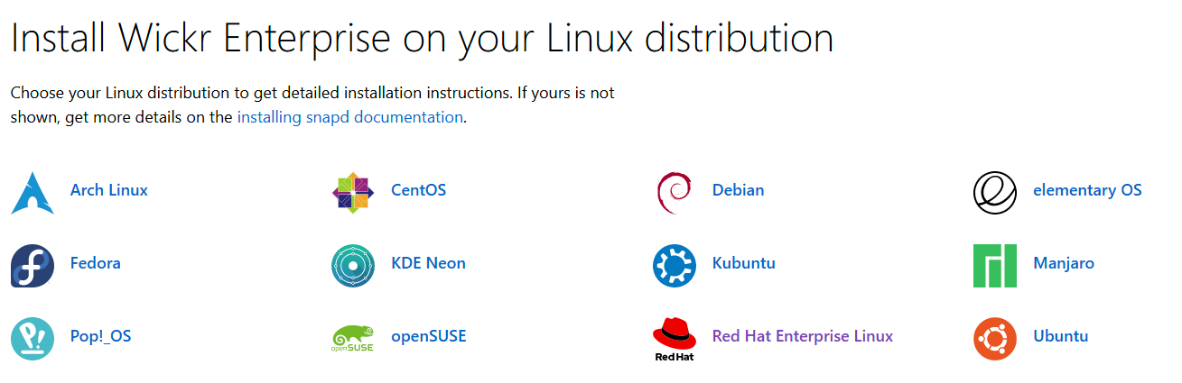

# Configure Wickr RAM via Deep link

Configuring your Wickr RAM client using the deep link auto configures your device pointing it to the Wickr RAM environment with minimal actions required by the end user.

To configure your device, please follow the instructions below:

1. Ensure the Wickr Enterprise client is not open.
2. Open a browser and navigate to [**https://ram.josce.net/install**](https://ram.josce.net/install) and select the **DEEPLINK** button, an open Wickr Enterprise window is displayed.
3. Select **Always allow**… and click **Open Wickr Enterprise**.

***WARNING: DO NOT CLICK CONFIGURE YOUR DEVICE.***

***THE DEEPLINK MAY TAKE A MOMENT TO PUSH THE CONFIGURATION TO YOUR DEVICE.***

1. **Wickr RAM User Acceptance Agreement** window opens, Click **OK**.
2. Login window opens, sign in with the email associated with your account.

* If you have a password set on JOSCE for another service, then use that password.
* For new users log in with your unique default password <10-digit DOD ID#>R@m. eg.1234567890R@m.

1. You will be prompted to change your password at first login.
2. The **Master Recovery Key** window opens, click **SAVE**

* If you cannot save the document onto your device, take a screenshot.

1. Click the check box **I have saved this recovery key in a secure place. Without it I will be unable to restore my accounts** click **NEXT** once saved.

# Configuring & Syncing Additional Devices

Wickr RAM users are licensed to install the client on up to five devices.  The following instructions describe options for syncing your messages across devices depending on your operational environment, e.g. cannot use cameras.

***Note:*** *You must have a Wickr account, both devices available, and be logged onto a Wickr device.*

## Scan QR Code

First option to sync a secondary device using a QR Code. However, it may not be suitable for all operating environments as a camera is required on the original device to use this method.  Please follow the instructions below:

1. Download and install the Wickr Client on a secondary device (see **Installing the Wickr Client**).
2. On your new device, sign in to the Wickr client.
3. On the **Transfer account and messages** page, choose **Scan QR code**.

A QR code page appears.

1. Open the Wickr app on your original device.
2. In the notification window, choose **Approve**.
3. Hold the QR code on the new device in front of the camera of the original device.

The Wickr app will automatically begin to sync your existing data to your new device.

1. When the sync is complete, a **Welcome to Wickr Enterprise** window appears on your new device.

## Manual Code Entry

Secondary option —for environments without cameras—a manual code can be entered. Please follow the instructions below:

1. Download and install the Wickr Client on a secondary device (see **Installing the Wickr Client**).
2. On your new device, sign in to the Wickr client.
3. On the **Transfer account and messages** page, choose **Enter code**.

A window with a code appears.

1. Open the Wickr app on your original device.
2. In the notification window, choose **Approve**.
3. On the **Enter Code Manually** page, enter the first six characters of the code displayed on your new device. Confirm that the codes match visually, and then choose **Continue**.

The Wickr app will automatically begin to sync your existing data to your new device.

1. When the sync is complete, a **Welcome to Wickr Enterprise** window appears on your new device.

# Recovering a Device

If you no longer have access to your original device, you can recover rooms but not history by using your Master Recovery Key (MRK). Please follow the instructions below:

1. On the **Transfer** **account and messages** page, choose to **Continue without transferring**.
2. Select **Use master recovery key**.
3. Enter your master recovery key and click **Recover**.

If you're having any issues with the downloading, installation, configuration, or syncing of Wickr on your desktop devices, please contact the service desk at:

Email: [**arma_afsof_servicedesk@gdit-ext.com**](mailto:arma_afsof_servicedesk@gdit-ext.com)

Phone: +18503745853 | +18334570457